**Student name: DUONG TRUNG TIN**

**Student ID: SE161845**

**Class: SE1716 – PRJ301**

**BOOKSTORE WEBSITE**

**Software Requirement Specification**

– HCM, July 2023 –

**Table of Contents**

I. Overview 3

1. Introduction 3

2. System Functions 4

II. Functional Requirements 5

1. Login 5

2. Register 5

3. Show homepage 6

4. Search Milk Tea by name 8

5. Show the quantity and product user want order 8

6. Update Order 8

7. Delete Order 9

8. Notice of successful order 9

9. Notice of successful order 10

10. Admin page 10

11. Manage account 11

12. Manage book 11

# I. Overview

## 1. Introduction

My project is about the book shopping website. My web includes user login functions to buy products and update product, remove products when not in use.

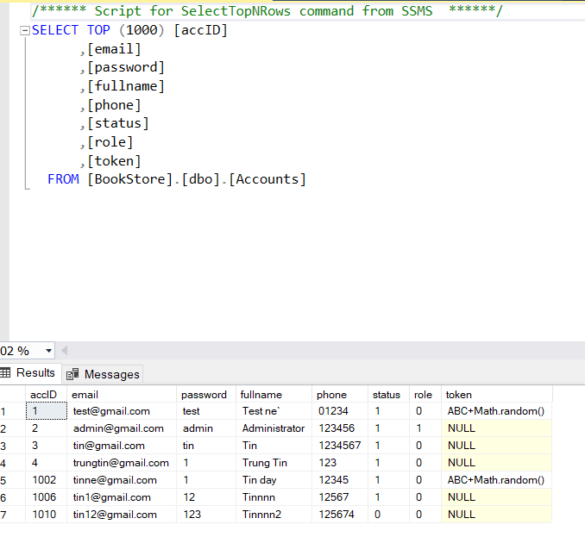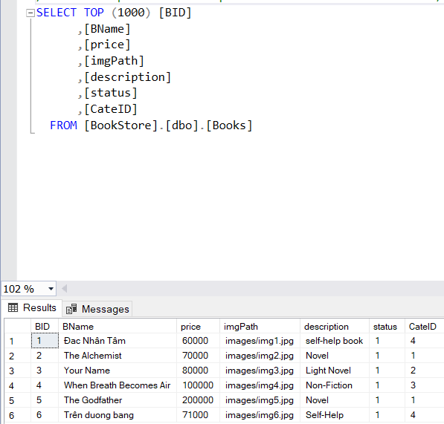

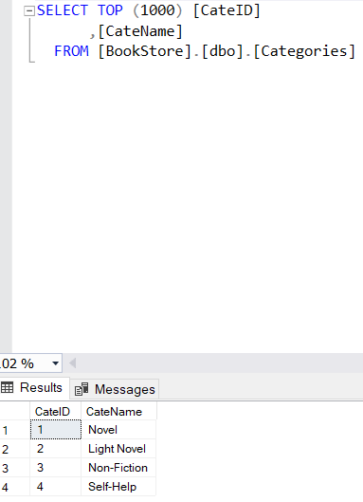 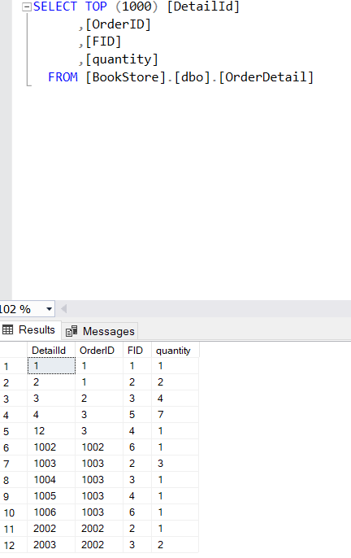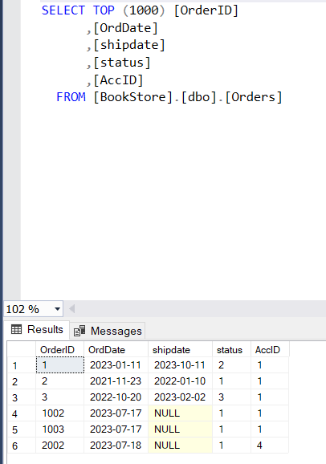

## 2. System Functions

#### a. Screen Flow

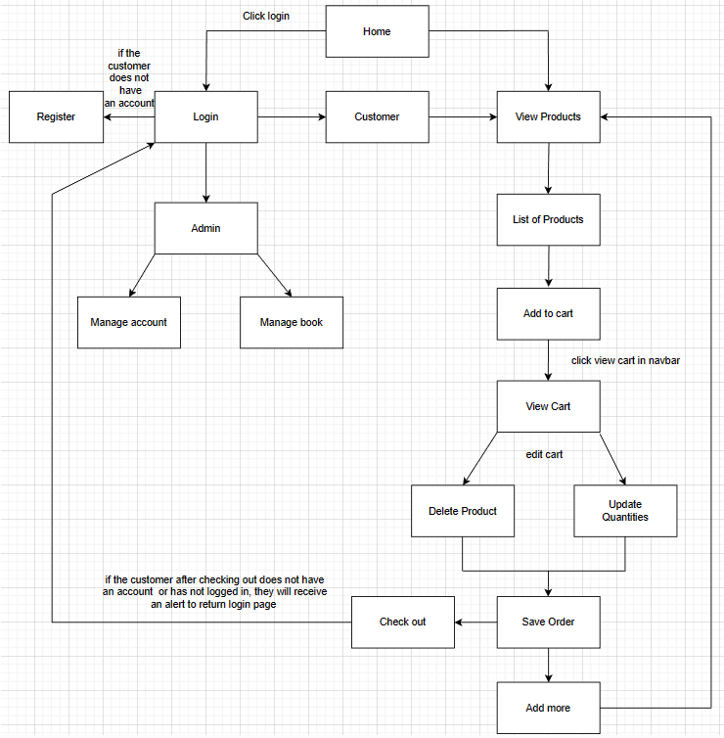

*[This part shows the system screens and the relationship among screens. You can draw the Screens Flow for the system in the form of diagram as below]*

#### b. Screen Details

*[Provide the descriptions for the screens in the Screens Flow above]*

***b.1 User Wed Application***

|  |  |  |  |
| --- | --- | --- | --- |
| **#** | **Feature** | **Screen** | **Description** |
| 1 | Get list of books | Home Page | List of books |
| 2 | Get milk tea detail | View Cart | Contains books details about books information, quantities textbox, add to cart button and confirm cart |
| 3 | Login account | Login page | Contains text box to input username and password, login button, register link |
| 4 | Register account | Register page | Contains text box to input user information, register button |
| 5 | View order detail and log out | Personal page | View order detail and log out button |
| 6 | Manage Account | Manage Account page | Contains user’s information, role and block/unblock account button. |
| 7 | Manage Book | Manage Book page | Contains book’s information, price, image, description |

* …

# II. Functional Requirements

## 1. Login

* Function trigger: after clicking login button or click the button to milk tea without logging in
* Function description: The system allows users to use their username and password to log in to the system as customer
* Screen layout:

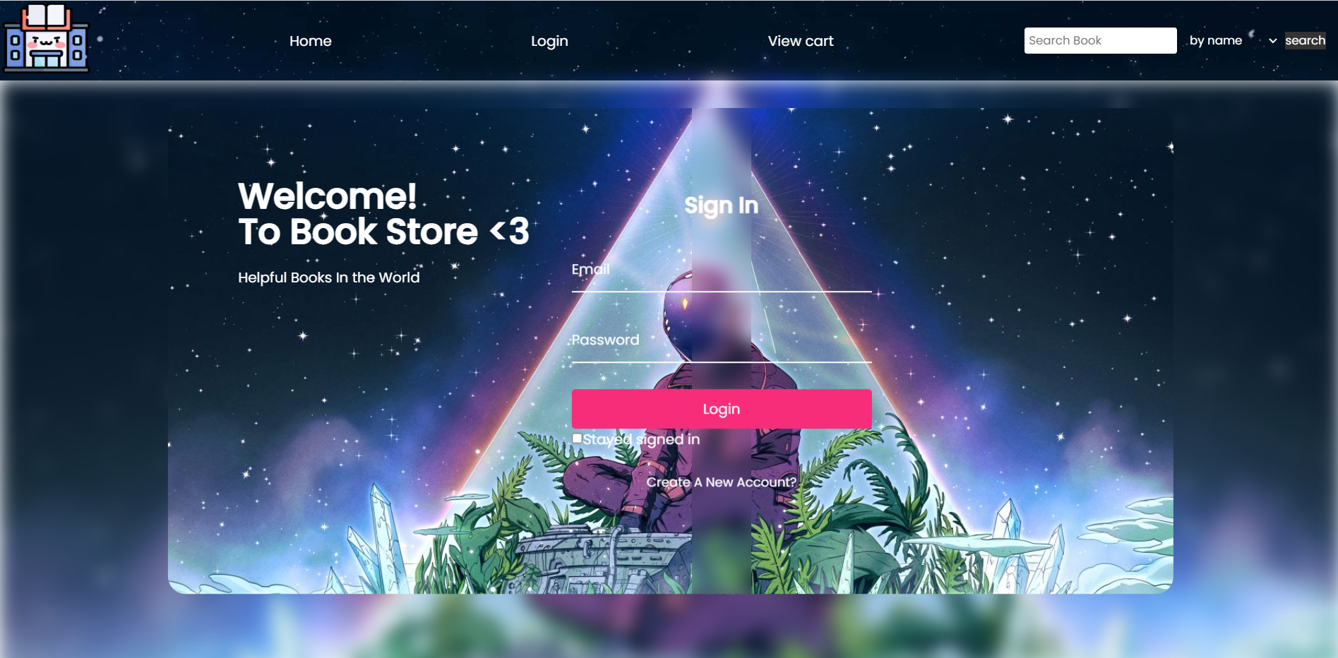

## 2. Register

* Function trigger: after clicking register button
* Function description: The system allows users to register for an account
* Screen layout: 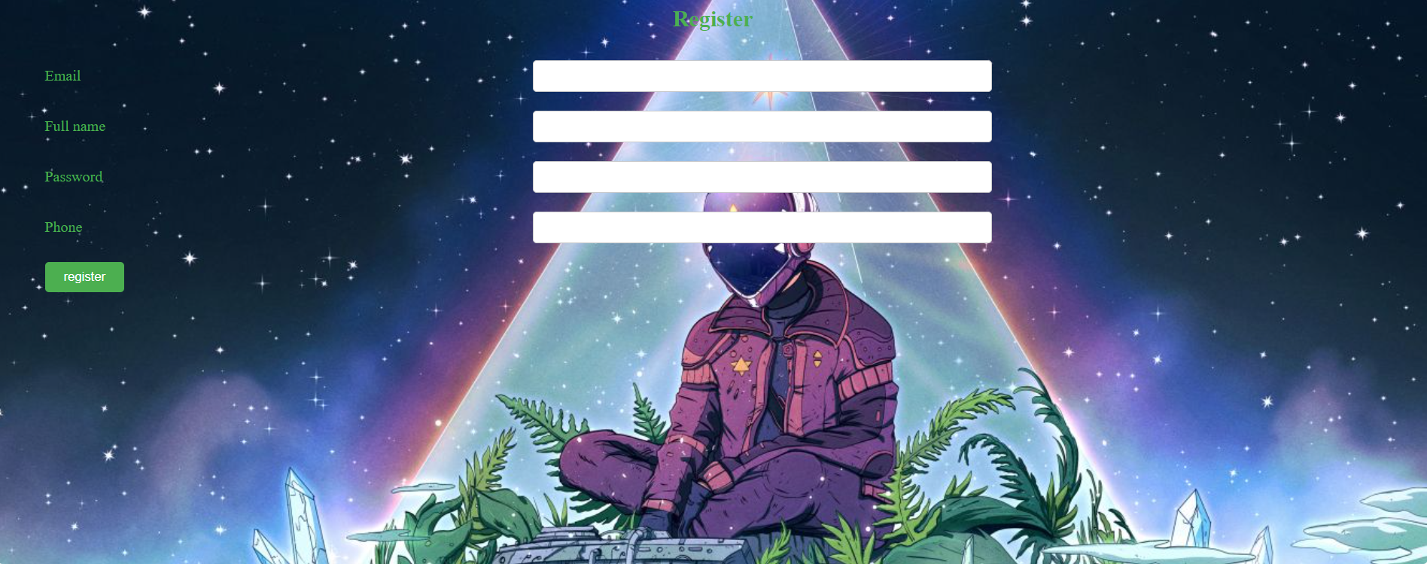

## 3. Show homepage

* Function trigger: after the clicking “Home” link or homepage tab
* Function description: the system shows the homepage for user
* Screen layout:



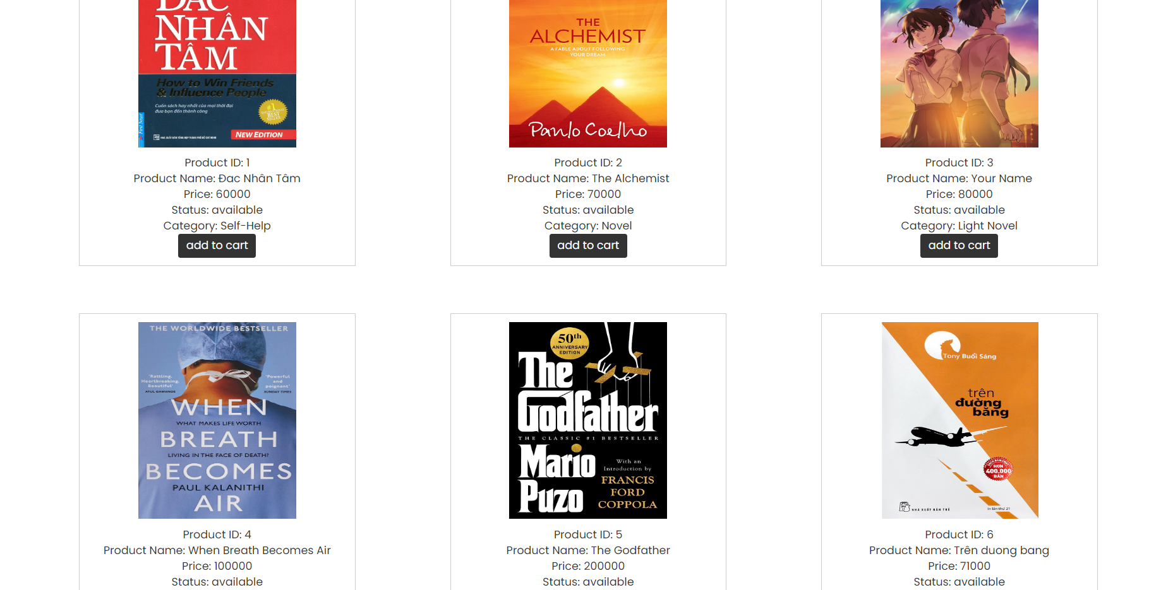

## 4. Search Milk Tea by name

* Function trigger: after choose Name book clicking search button
* Function description: Display milk tea according to user’s search request
* Screen Layout:

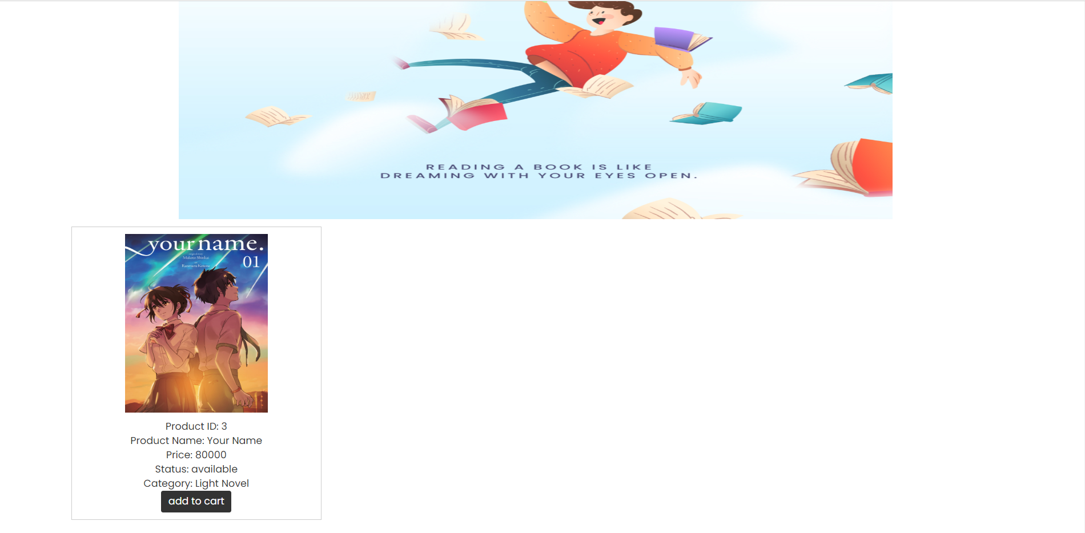

## 5. Show the quantity and product user want order

* Screen layout: 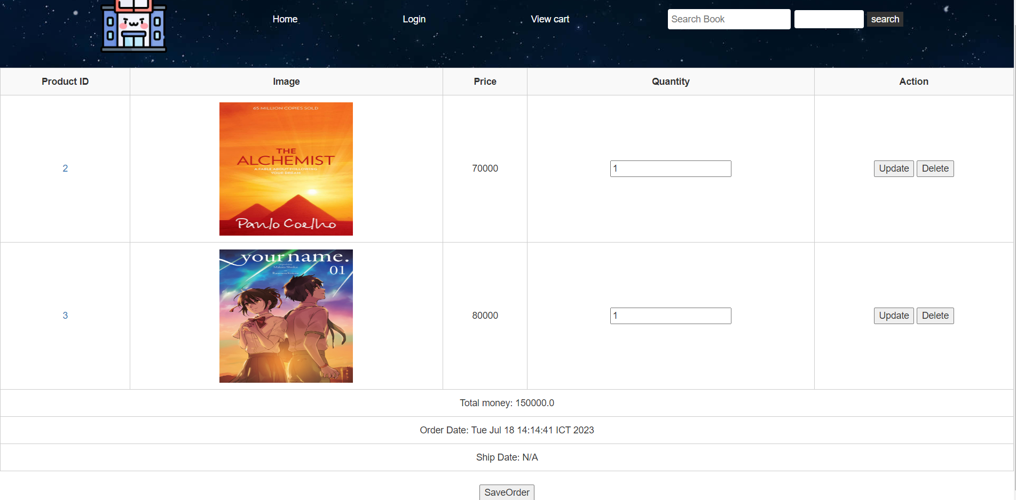

## 6. Update Order

* Function trigger: after choosing update button of book
* Function description: display user’s information, quantities, price, action Update
* Screen layout: 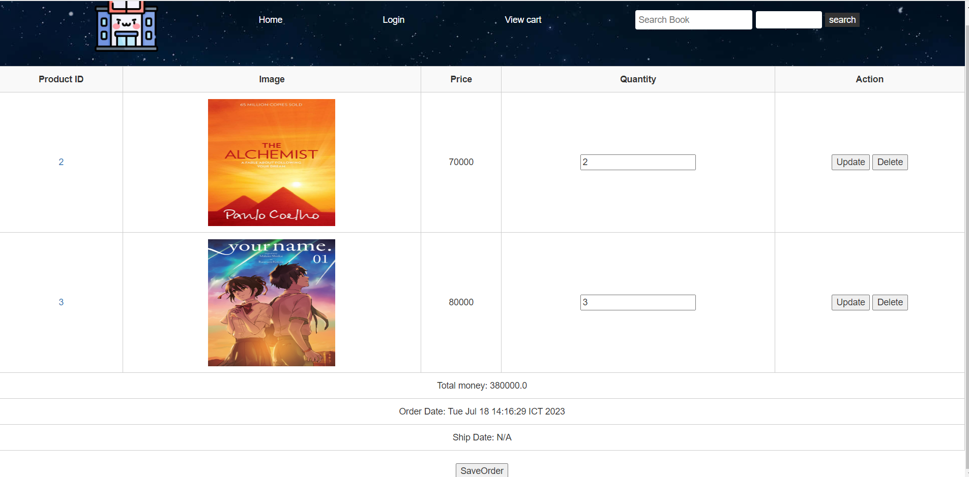

## 7. Delete Order

* Function trigger: after choosing delete button of book
* Function description: display user’s information, quantities, price, action Delete
* Screen layout:

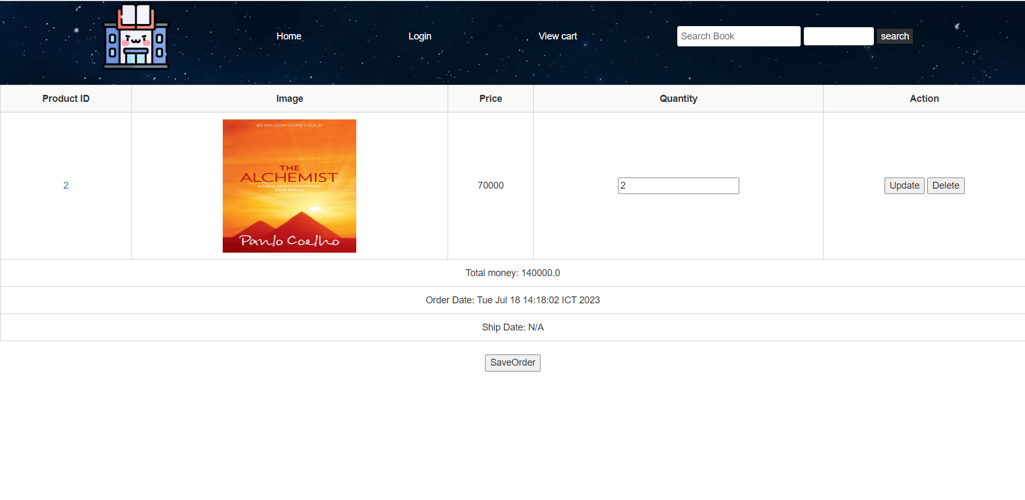

## 8. Notice of order fail

* Function trigger: after clicking SaveOrder button
* Function description: if user don’t have account message is displayed on the confirm Check out. Return login page to login account
* Screen layout:

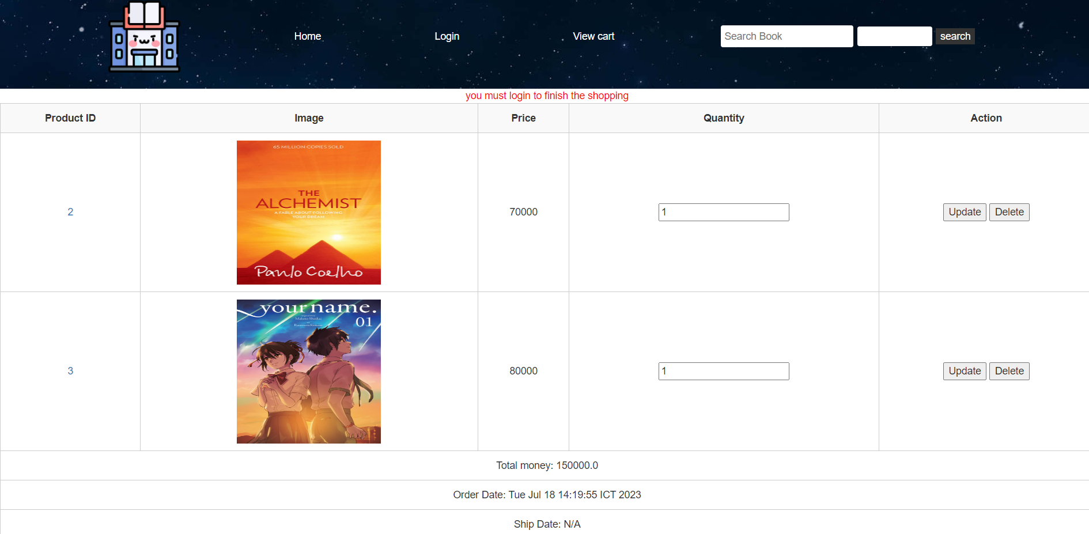

## 9 Notice of successful order

* Function trigger: after clicking Check out
* Function description: a success message is displayed on the confirm Check out
* Screen layout:

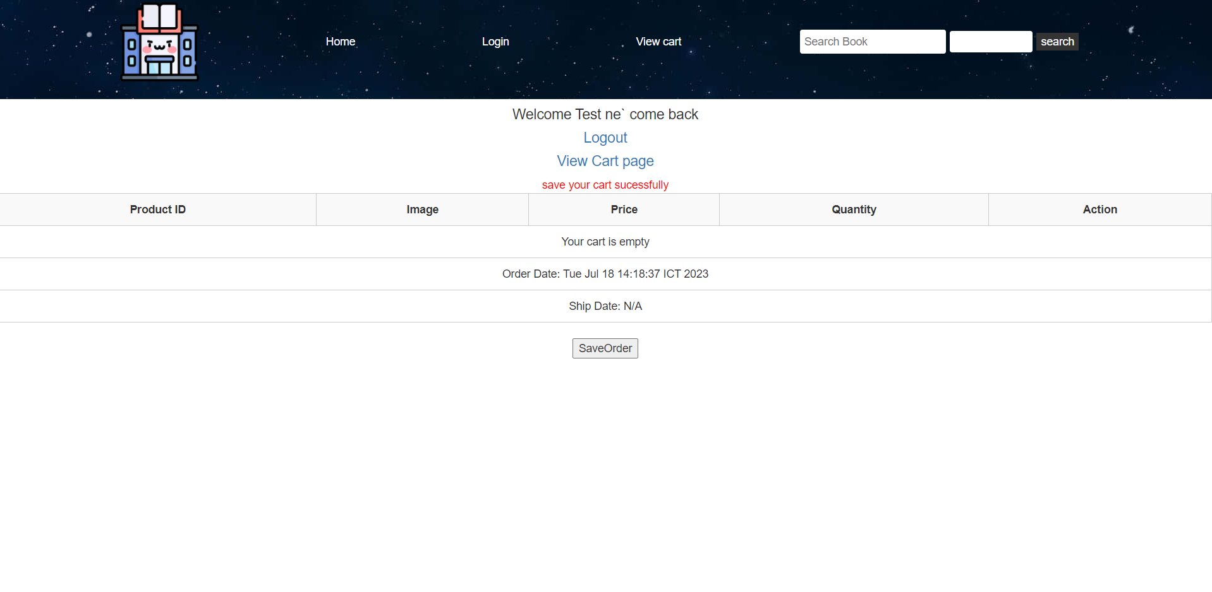

## 10. Admin page

* Function trigger: after login by account administrator
* Function description: show admin page
* Screen layout:

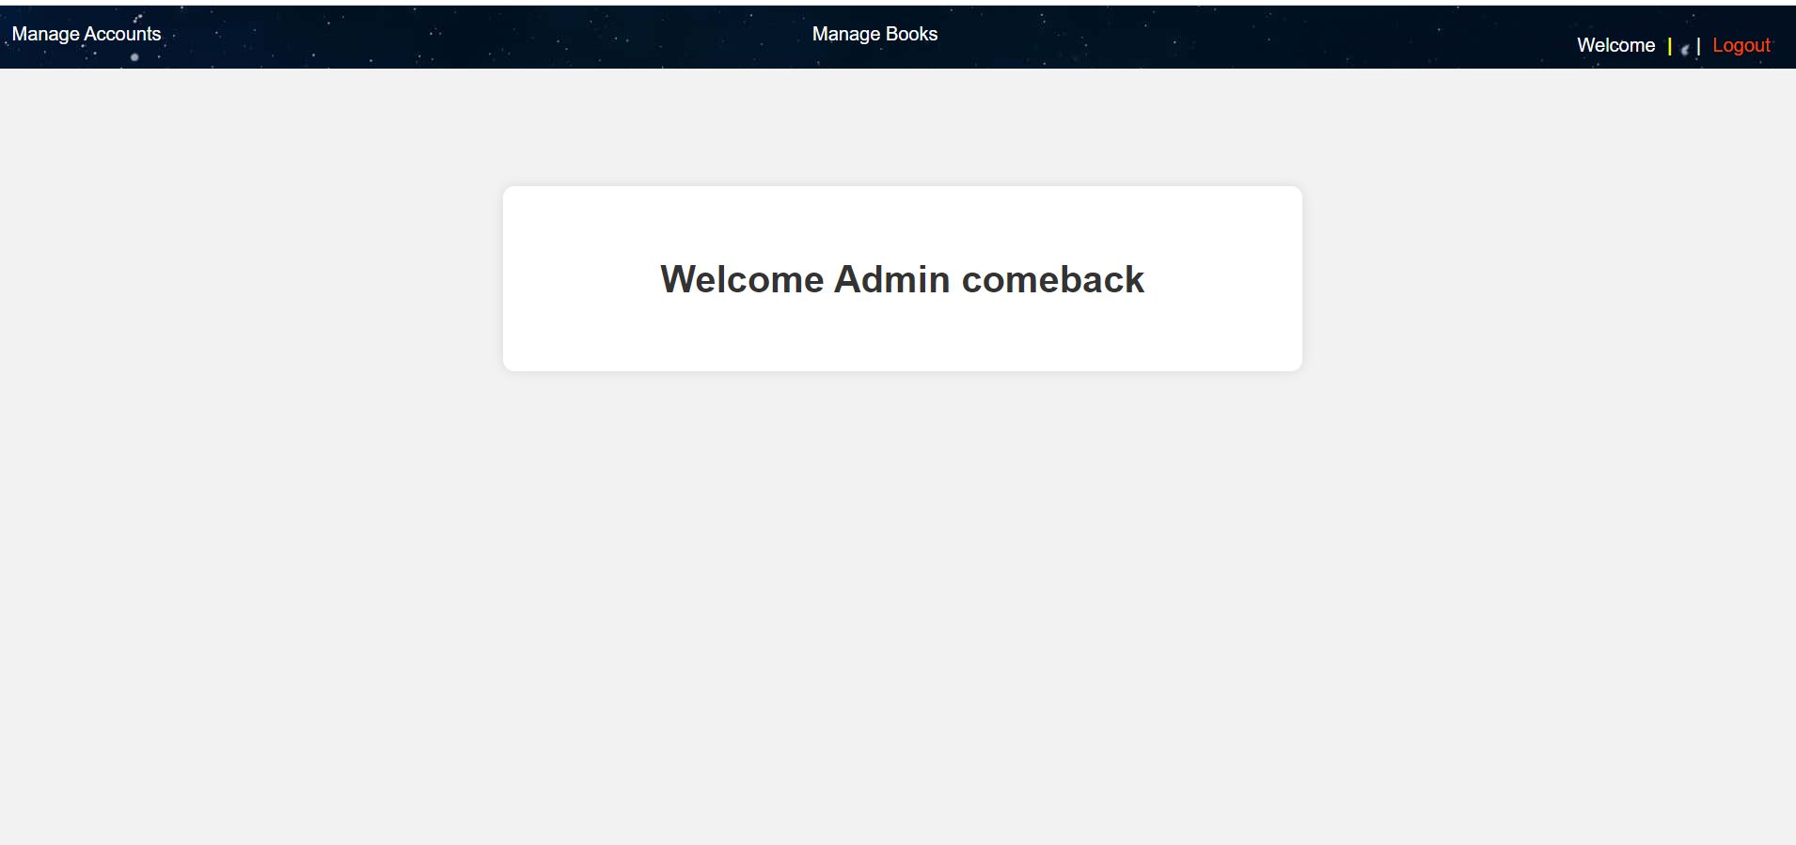

## 11. Manage account

* Function trigger: after clicking Manage account in Admin page
* Function description: show list of accounts
* Screen layout:

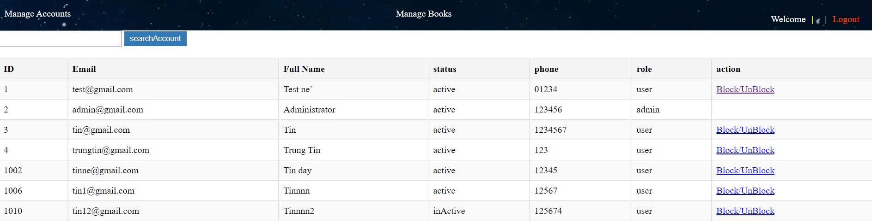

## 12. Manage book

* Function trigger: after clicking Manage book in Admin page
* Function description: show list of book
* Screen layout:

